Read chapter 6 in your textbook. The following review questions should help guide your reading. **Points possible 35**

For each question, you should give a correct answer (as best you know it) or provide an intelligent question regarding the reading that applies to this question and explains why you could not answer the question. (Please note that "I didn't understand any of this" isn't a question, isn't intelligent, and has spelling and grammar errors. It will receive 0 points.)

**Make sure to show your work. Answer the questions using your own words and understandings on the chapter materials.**

1. R2. **(2 Points)** If all the links (proper delivery of frames) in the Internet were to provide reliable delivery service, would the **TCP reliable delivery service be redundant?** Why or why not? Explain the reasons based on what we have learned from (reliable TCP) and routing concepts.
   1. It would still be needed because even though we can confirm that they were delivered, it does not mean that they were delivered in the correct order and to the correct destination which is what the TCP reliable delivery service does. So it is still needed
2. R9. **(2 Points)** How big is the MAC address space? Provide an example of a MAC address. The IPv4 address space? Provide an example of a class C IP address. How big is the IPv6 address space? Provide an example of a Link-local IPv6 address
   1. MAC address space is a 48-bit space with over 281 trillion possible combinations.
      1. 00-14-22-01-23-45
   2. IPv4 address space is 32 bits
      1. 172.16.254.1
   3. IPv6 is 128 bit space
      1. 2001:0:9d38:6ab8:1c48:3a1c:a95a:b1c2
3. R11. **(2 Points)** Why is an ARP query **sent** within a broadcast frame? Why is an ARP **response** sent within a frame with a specific destination MAC address? Explain this question with an example that computer **A** connects to a new switch and wanted to communicate with computer **B** that is already connected to the same switch.
   1. Because the target’s MAC address is not known and unable to send a unicast frame to the target.
   2. Host A would send a message asking is anyone is under a certain IP address and broadcast it with its personal MAC address all part of the ARP querery. Host B would then recognize that Host A is calling its IP and reply with a confirmation and MAC address
4. R14. **(2 Points)** Consider Figure Below. How many subnetworks are there, in the addressing sense of Section 4.3?

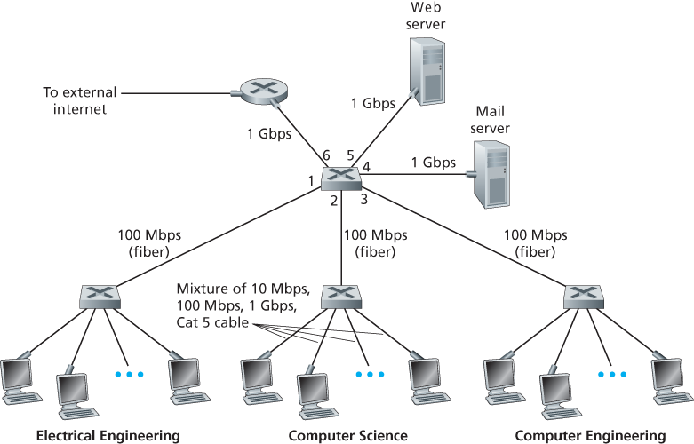

There are a total of 3 subnetworks

1. **(4 Points)** Consider the network setup below PC1 is sending data to PC2. All devices are ARP complete. In this scenario, you are given a blank frame to build. Determine the destination and source MAC Address, and the source IP and the destination IP address that would correctly build the frame as specified. All information below will not be used. **Read 6.7 Retrospective**: A Day in the Life of a Web Page Request if you can’t figure this out.

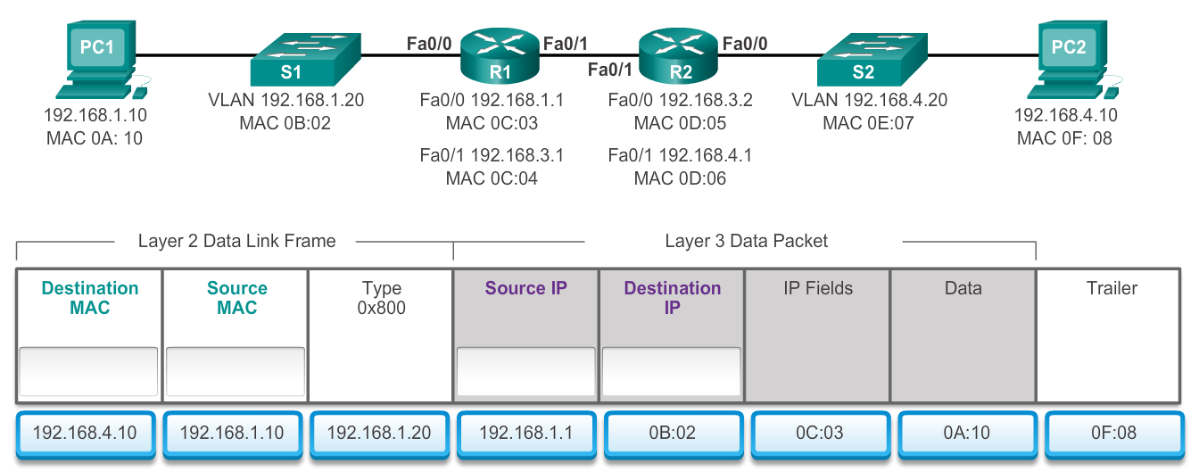

1. Destination MAC: 0C:03
2. Source MAC: 0A:10
3. Source IP: 192.168.1.10
4. Destination IP: 192.168.4.10
5. **(4 Points)** Consider the network setup above. R2 has received the frame from PC1 and now ready to send it to PC2. All devices are still ARP complete. In here, build the frame to transfer the data from **R2** to **PC2**. All information above will not be used.
6. Destination MAC:0F:08
7. Source MAC: 0D:05
8. Source IP: 192.168.4.1
9. Destination IP: 192.168.4.10
10. **(4 Points)** P1. Suppose the information content of a packet is the bit pattern 1110 0110 1001 1101 and an even parity scheme is being used. What would the value of the field containing the parity bits be for the case of a two-dimensional parity scheme? Your answer should be such that a minimum-length checksum field is used.
    1. We use a 4x4 matrix

|  |  |  |  |  |
| --- | --- | --- | --- | --- |
| 1 | 1 | 1 | 0 | 1 |
| 0 | 1 | 1 | 0 | 0 |
| 1 | 0 | 0 | 1 | 0 |
| 1 | 1 | 0 | 1 | 1 |
| 1 | 1 | 0 | 0 | 0 |

1. **(4 Points)** Consider the 5-bit generator, G=10011 and suppose that D has the value 0101101010. What is the value of R? Show your work.
   1. Extra bits = (5-1) = 4
      1. 1011010100000
      2. 10011
      3. 0010110100000
      4. 10011
      5. 0000101100000
      6. 10011
      7. 0000001010000
         1. R value = 0101101010000
2. **(5 Points)** A Pure-Aloha network transmits a 400-bit frame on a shared chanal of 100 kbps. What is the throughput if a system produces 200 frames per second?
   * 1. Throughput = G x e-2G = (.184) = 200(.184) = 36.8 frames
   1. What will be throughput for slotted aloha?
      1. G = 1 S=Gxe-G=0.368 = 200(.368) = 73.6 frames
3. **(5 Points)** P14. Consider three LANs interconnected by two routers, as shown below

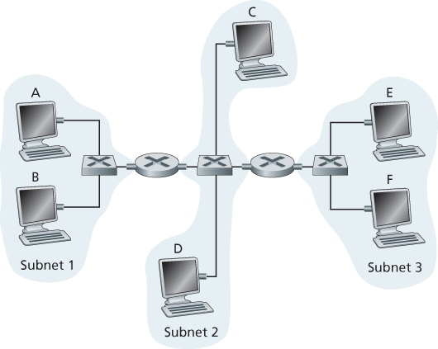

* 1. Assign IP addresses to all of the interfaces. For Subnet 1 use addresses of the form 192.168.1.xxx; for Subnet 2 uses addresses of the form 192.168.2.xxx; and for Subnet 3 use addresses of the form 192.168.3.xxx.
     1. A: 192.168.1.1
     2. B:192.168.1.2
     3. C:192.168.2.1
     4. D:192.168.2.2
     5. E:192.168.3.1
     6. F:192.168..3.2
  2. Assign MAC addresses to all of the adapters
  3. Consider sending an IP datagram from Host E to Host B. Suppose all of the ARP tables are up to date. Enumerate all the steps, as done for the single-router example in Section 6.4.1.
     1. Destination MAC: 00:0A
     2. Source MAC: 00:0D
     3. Source IP: 192.168.3.1
     4. Destination IP: 192.168.1.2
        1. E broadcast message with Destination MAC address and other information to reply.
  4. Repeat (c), now assuming that the ARP table in the sending host is empty (and the other tables are up to date).
     1. Destination MAC: 00:0A
     2. Source MAC: FF:FF
     3. Source IP: 192.168.3.1
     4. Destination IP: 192.168.1.2
        1. E broadcast message with Destination MAC address and other information to reply.

192.168.3.1

192.168.2.1

192.168.1.1

E

C

00:0B

A

00:0D

00:0C

Router 2

Router 1

00:0A

D

B

F

192.168.2.2

192.168.1.2

192.168..3.2